Usman Basharat

000874782

LOGBOOK

COMP1635 – PROFESSIONALISM IN IT

Table of Contents

Introduction 2

Exercise 1: Business idea 2

Exercise 2: Learning Style Questionnaire 3

Exercise 3: Belbin’s Team Player 7

Exercise 4: CV Evaluation 9

Exercise 5: The STAR Technique 10

Conclusion 11

**References** 12

# Introduction

This logbook was based on five exercises that we had to complete weekly. The five exercises are business idea, learning style questionnaire, Belbin’s team player, CV evaluation and the STAR technique. All of these exercises are written below.

# Exercise 1: Business idea

**Idea: Recycling Electronics**

Over 42M electronic waste is found all over the world [1]. Essentially recycling electronics can be made possible by customers, or even stores, can send in their electronics that they do not need on the site. I feel that this can be a positive sign because one reason is that it is essentially recycled; second reason is that any item that can be replaced and, in mint condition, can be sold; and three, it does not go to waste. The product being sent to us can be done by delivery. We can run our own services to get these products of the customers. This would be a much better moved compared to the customers doing it themselves.

Since 1994, 15 mobile phones have been made [3]. Instead of this going to waste, it can be reused and made it for a better. This could be profitable by getting all the electronic waste and reusing it. This can be done by selling of any parts, or getting the product to be in mint condition and putting it on sale. The target market is aimed adults over 18. This business idea will run online only in the UK.

Other departments of the business can be to come up with new ideas and implementing it so that business can always consistent. Any profits that is made from other departments can be towards the services of this department. One major challenge of this is the funding relies on other departments. If the other departments are not performing, the income of this department will not work. This is a positive move for the business going forward, because any idea that can be sold for a huge profit would only make the business expand in brand name.

One major challenge to overcome whilst implementing it is trying to encouraging customers to send their old electronics. Over a long period of time, this could work.

# Exercise 2: Learning Style Questionnaire

Here is the completed version of the Honey and Mumford self-evaluation form.

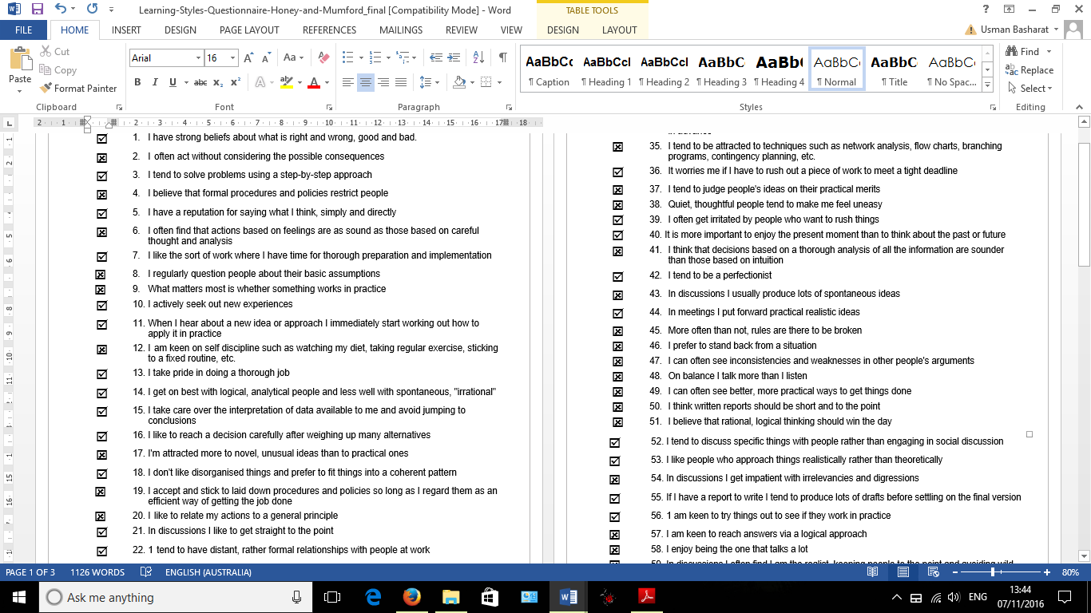

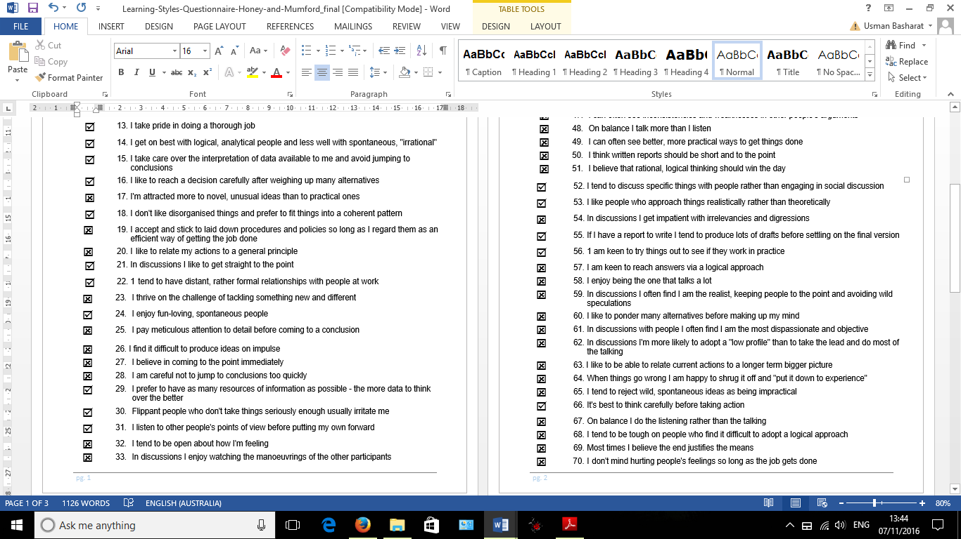

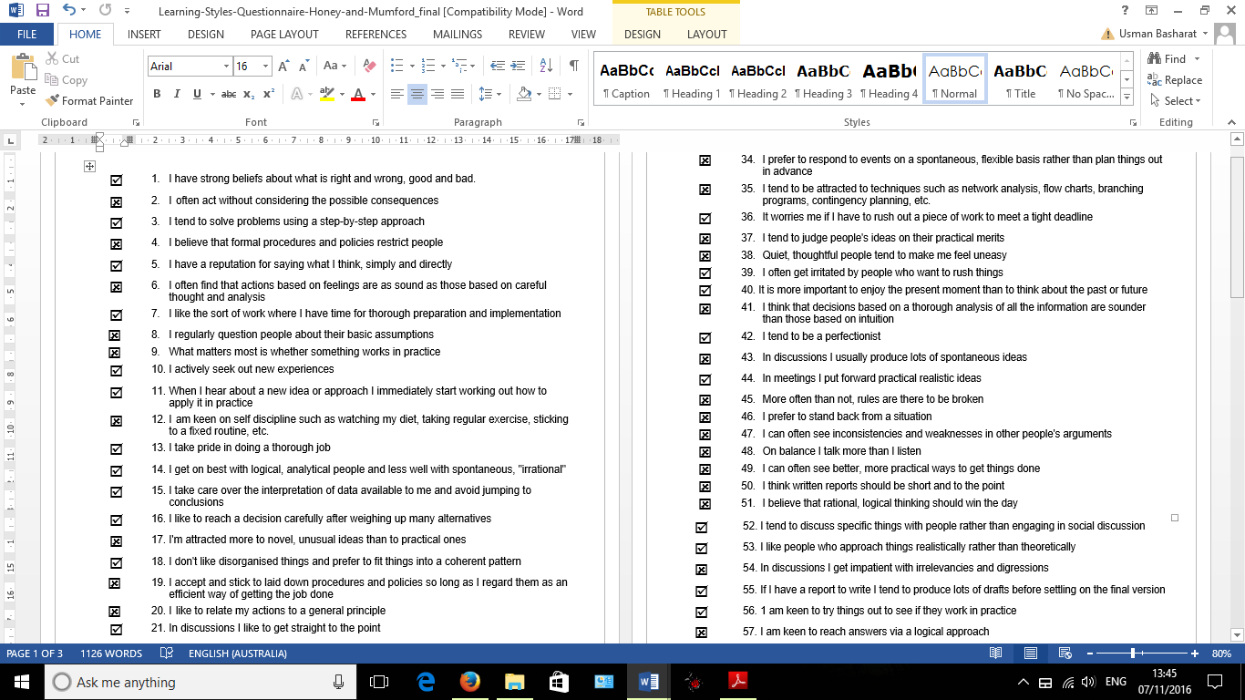

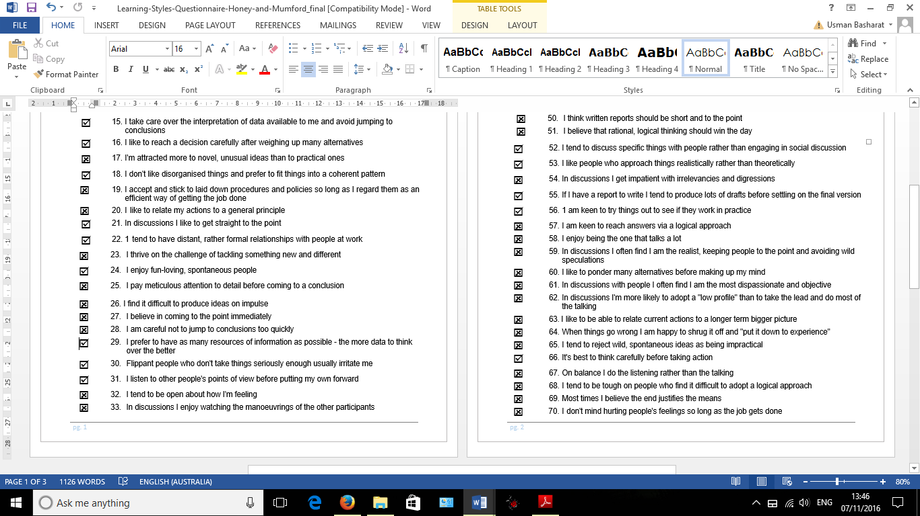

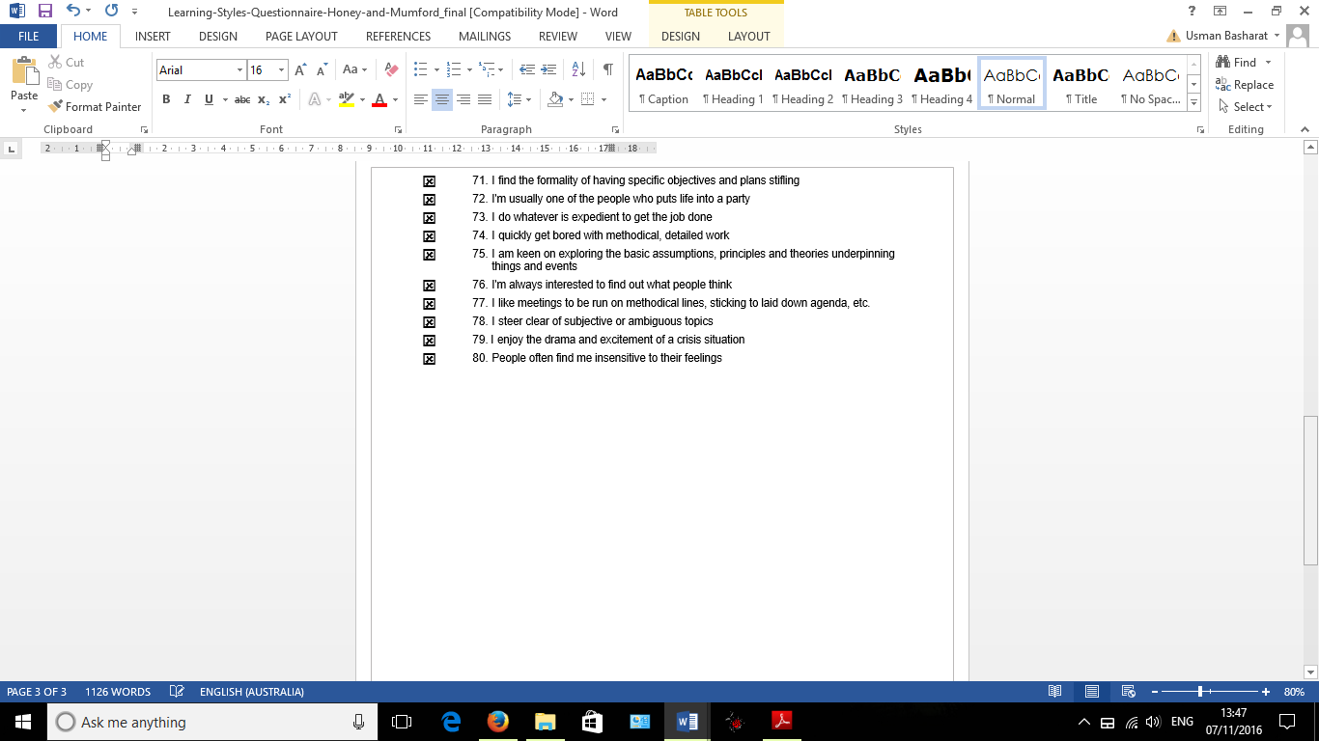

**Scoring and Interpreting the Learning Styles Questionnaire**

1. Self-evaluation form (Honey and Mumford) is completed above. As identified, here are the results. The yellow highlighted numbers are the ones that I have selected. As stated, the most I got is Reflector.

|  |  |  |  |
| --- | --- | --- | --- |
| 2 | 7 | 1 | 5 |
| 4 | 13 | 3 | 9 |
| 6 | 15 | 8 | 11 |
| 10 | 16 | 12 | 19 |
| 17 | 25 | 14 | 21 |
| 23 | 28 | 18 | 27 |
| 24 | 29 | 20 | 35 |
| 32 | 31 | 22 | 37 |
| 34 | 33 | 26 | 44 |
| 38 | 36 | 30 | 49 |
| 40 | 39 | 42 | 50 |
| 43 | 41 | 47 | 53 |
| 45 | 46 | 51 | 54 |
| 48 | 52 | 57 | 56 |
| 58 | 55 | 61 | 59 |
| 64 | 60 | 63 | 65 |
| 71 | 62 | 68 | 69 |
| 72 | 66 | 75 | 70 |
| 74 | 67 | 77 | 73 |
| 79 | 76 | 78 | 80 |
|  |  |  |  |

TOTALS 3 11 7 6

**Activist Reflector Theorist**  **Pragmatist**

Reflector is taking a step-back and learning off others. I agree with this partially and disagree with it partially too. I feel like this because I learn in two different ways. I accept I can learn by stepping back and learning off other people, however, I can relate to being practical and doing it myself. I also think that I can be a pragmatist

In order to improve my skills, I can improve by taking charge of a group more often. Telling people what to do, and being confident about it. I can improve this by asking my peers’ opinion and practicing in the library more often. I sense that I can make a rash decision when I am under pressure. I am improve this by taking my time to think about the decision that is going to be made. Moreover, improving my presentation skills by practicing more. Lastly, the main action plan that I need to stay on top on is being organised and on time with assignments. I can improve this by making a guide to tell me when I need to give in my assignments. This would help me in the future.

# Exercise 3: Belbin’s Team Player

1. Identifying a team role I most resonate with and I included my team’s role too.

* Ahmed: Co-ordinator, Team Worker, Monitor
* **Usman: Implementer, Complete Finisher, Co-ordinator**
* Zuber: Team Worker, Complete Finisher
* Steven: Co-ordinator, Sharper

**Team’s Five Strengths:**

1. Adapting to different situations so one team member can step down to a different role if necessary
2. Strive for perfection and aiming to correct as many errors as we can
3. High standards – making sure we can have high expectations and goals in what the task is to complete
4. Being reliable conservative and efficient in whatever comes across.
5. Clarifies goals. Making sure we keep in track to what we need to complete.

**Team’s Five Weaknesses:**

1. Two members in our team have complete finisher. This can be changed by only one person having the role to do this role. The person’s role that is changed can be plant so our team is versatile.
2. As identified the roles of each member, we do not have a person that can, mentally, drive the team to do well. This would benefit the team well, because it can improve results.
3. As shown, we have co-ordinators in our team. This equals to two team members giving out instructions when there is only needed of one person. One person can lead the team.
4. The weaknesses is someone whom can organise the team. This can be the person whom is stepping down as co-ordinators.
5. As a team, the weakness is having someone whom is monitoring the situation and having a person who is lazy. This is a problem and can effect the outcome.

**Peer review**

**Team member’s contribution to the group sessions**

My group member’s contribution, during the group sessions, has a good impact. The strengths that I have noticed is that he is very adaptable with whatever he is doing. For example, if one person is not in, he can suggest ways in which the person’s work can be covered. This is how a team member should be. Moreover, he is on time with his work. I have noticed that he completes his work on time.

However, the negative is he should do a background check before every topic so that he can suggest more ideas and not be stuck. Although he is on time with his work and adaptable, I have seen parts where he is too quiet during the sessions. Being actively engaged with work is also important too.

# Exercise 4: CV Evaluation

**CV: Gillian Gail Goodwin**

The first improvement that is needed from this CV is the font is too fancy and almost unreadable. For any employer, this should be the first priority for the font to be clear and readable for any person. To improve this, Gillian should change the font so that other individuals can read it. Employers would not give you extra points for fancy font.

The second improvement is the details can be cut down. This takes half the page and does not need to take that much space. This could be complete by putting under ‘Hobbies and Interests’, since this is unprofessional by leaving one line that shows incompletion on your CV. This gives a bad impression to the employer looking at your CV. Each section that is written on your CV needs to be complete.

As for the cover letter that has been written, as specified on the specification, the cover letter needs to have a brief introduction about yourself. By including only one line shows that it is not complete again. Furthermore, greeting on the email using sir/madam shows that the candidate is professional. All cover letters should include a professional formal formatting

Another mistake that I have noticed is the Referees’ contact details is missing. If this candidate was successful, the referees are always contacted. This being missing on your CV shows that the whole CV needs to be checked before applying for any job.

**CV: Peter Rogers-Smyth**

The first impression that I got from this CV is that it is too messy and all over the place. It does not have clear sub-heading and does not stand out. To improve this, this candidate can take responsibility by having a structure to the CV with clear and bold sub-headings so that any employer can take notice. Under ‘Education’, the user only needs a few lines to discuss grades he got. For example, he can write 8 A* to C. This example states the school within one line and states what rather grades the imaginary candidate got.

Another improvement this candidate cannot being informal in an email. Using statements such as, “Hiya Steve” and “Cheers Pete” shows as if he is speaking to a friend. This candidate needs to improve on how to write a professional email with the correct spelling and grammar too. Using professional greetings and endings such as, “Dear Sir”, and “Your Sincerely Peter”. This shows a professional attitude too. By stating you have “a lot of interviews”, puts the employer off. This should be an introduction about yourself. This should not be about when you can fit the time for the interview when you have not even received any yet.

# Exercise 5: The STAR Technique

**Competency 1 (chosen from the graduate trainee competency list)**

**Evidence for this competency**: Must demonstrate a CREATIVE approach to PROBLEM-SOLVING.

**Situation:** We worked within groups and had six tasks to separate. We split it within the group

**Task:** Being able to complete a bunch of tasks for Introduction to UNIX and a report to complete

**Action:** I managed to split the tasks so that it can be done fairly

**Result:** We resulted in getting 100%

**Written as a statement:** During my second week at University, we had an assignment in Communication module to complete. We had six tasks to complete in Introduction to UNIX. Therefore, I managed to be creative and let two members to complete two tasks and the last two one person can do each. This was important as the deadline was within one week to do the practical work and create a report on it too. This creative approach was important, as the report was needed to be complete as well. The same person whom had done the practical work did the analysis on it too. This made the problem easier to complete and we reaped the rewards and gained 100% for this particular coursework.

**Competency 2: (chosen from the graduate trainee competency list)**

**Evidence for this competency**: Must demonstrate a FLEXIBLE approach to managing the workload.

**Situation:** We worked as a group of two and my pair did not attend

**Task:** Presentation on Internet of Things

**Action:** Completed the extra work for the presentation to be complete

**Result:** I completed the presentation ended with 67%

**Written as a statement:** I feel that this was a flexible approach to managing a workload, because as a group of two, we had to research and present a specific topic. We had our own part to complete and we practiced each part ourselves. However, when the day came to present, the person was ill and was unable to attend. Therefore, I had to do all of the work myself and present the topic of his research too. I found that it nervous without presenting with my group member, but when I completed it and I found it that I did all of the workload when it was supposed to be split in half. I ended up getting 67%.

# Conclusion

In conclusion, I felt that I have learnt many skills during the five exercises we have complete. During each exercise, we used different skills for each exercise. For example, Exercise 2 we had to analyse ourselves and a week later, on to Exercise 3, we went on to analysing a team. By doing these sort of exercises, we can use them not only outside. For example, CV evaluation can be used by evaluating our own CV. In addition, by identifying the learning style, we can make certain changes to the way I revise in order to get the best of what I learnt.

# **References**

1. **“Facts And Figures on E-Waste and Recycling". *Electronics Take Back Coalition*. N.P., 2016. [Online]. Available at:** [**http://www.electronicstakeback.com/wp-content/uploads/Facts_and_Figures_on_EWaste_and_Recycling.pdf**](http://www.electronicstakeback.com/wp-content/uploads/Facts_and_Figures_on_EWaste_and_Recycling.pdf)

**(Accessed 3 Oct. 2016)**

1. **"Business Plans: A Step-By-Step Guide". *Entrepreneur*. N.P., 2012. [Online]. Available at:** [**https://www.entrepreneur.com/article/247574**](https://www.entrepreneur.com/article/247574)

**(Accessed 3 Oct. 2016)**

1. **Lane, Edwin. "Where Many Of Our Electronic Goods Go To Die - BBC News". *BBC News*. N.P., 2016. [Online].Available at:** [**http://www.bbc.co.uk/news/business-35244018**](http://www.bbc.co.uk/news/business-35244018)

**(Accessed on 3 Oct. 2016)**